Length – enough time available to answer questions to the best of your ability

Format of extended answer – multiple parts rather than the essay format

Did you feel adequately prepared (breadth of content and level of difficulty)?

Did knowing the mark you needed to get help or hinder your study plans?
SECTION ONE – MULTIPLE CHOICE (20 marks)

A runner’s progress was tracked as shown below
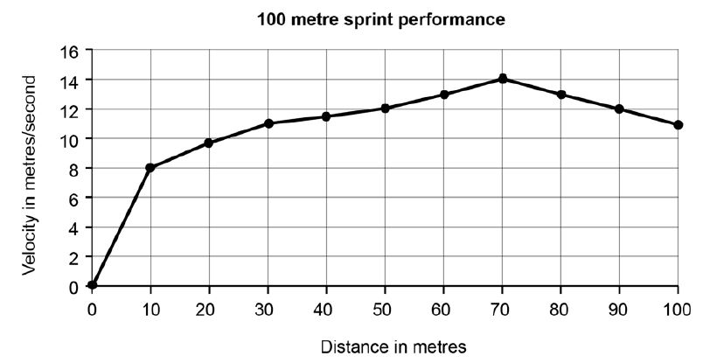

- Which one of the following represents the most accurate interpretation of the data from the graph?
- he runs up a hill then heads down a small slope at the end
- he shows uniform acceleration throughout most the run
- his displacement is greatest at the 70 metre mark
- he decelerates after the 70 metre mark

- The optimum angle of release for objects traveling maximum distance is:
- determined by the centre of gravity of the athlete throwing it
- generally lower than the 45 degrees of release for a situation where the release point is higher than the landing
- more than 45 degrees
- increased for sports where velocity of release is the most critical factor

- In soccer, the goalie must respond to ‘shots on goal’ as quickly as possible. Although not ideal, a goalie with lower levels of speed or agility may still be successful if they possess an exceptional level of which of the following components of fitness?
- cardiorespiratory endurance
- coordination
- flexibility
- reaction time

- In basketball, a player who is fouled while taking a shot is often rewarded a ‘free throw’, whereby the player is allowed to attempt a shot without any defenders involved. The basketball free throw would be classified as which of the following motor skills?
- open, discrete and fine
- closed, discrete and gross
- closed, serial and gross
- open, serial and fine

- Muscle fibres can be classified into two distinct types. Type II – white muscle fibres are best characterised by:
- slow speed of contraction, high endurance qualities, large in size
- low in endurance qualities, anaerobic, large in size
- prevalent in the quadriceps muscle of marathon specialists and postural muscles
- having an extensive blood supply
- When the hamstring muscle is contracts concentrically, what action is occurring about the knee joint?
- eccentric extension
- flexion
- isoflexion
- isokinetic stabilisation

- Muscles have four main characteristics. One of the characteristics is ‘extensibility’ and it is characterised by
- the muscles elasticity
- the body’s adiposity or body fat
- a muscle’s ability to develop tension whilst shortening
- the muscles ability to stretch beyond its normal resting length

- When commencing exercise, it takes time for oxygen consumption to increase, resulting in:
- an oxygen deficit
- a tidal volume
- an arteriovenous difference
- anaerobic metabolism of fat

- The aerobic system:
- is capable of producing the largest amount of ATP
- uses glucose to breakdown ADP with a by-product of ATP
- both a) and b)
- is least likely to be used at rest

- Blood is redistributed at the start of exercise with the assistance of:
- a decrease in stroke volume
- vasoconstriction and vasodilation
- maximal oxygen consumption
- lactate threshold

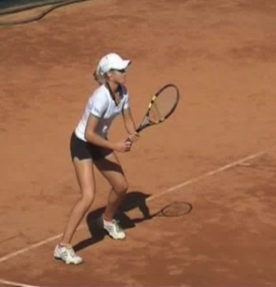
- What type of attention focus does a tennis player need when preparing to return a serve?

- broad internal
- broad external
- narrow internal
- narrow external

- The IZOF:
- is a model used to understand the influence of emotions on performance
- proposes that individual athletes react differently to the same level of experienced emotion
- is where the ‘OF’ represents the words ‘optimal functioning’
- all of the above

- Which of the following terms complete the statement below correctly?
To accomplish a forward kicking action of the foot, the knee joint ___________ and the hamstring muscles act as the ___________ and the quadriceps act as the ______________

- extends, antagonist, agonist
- flexes, antagonist, agonist
- extends, agonist, antagonist
- flexes, agonist, antagonist

- When an athlete is over-aroused for a specific situation, such as deciding to pass the ball or shoot for goal, they:
- should use progressive relaxation to reduce the cognitive symptoms of anxiety
- will likely increase the field of information that is attended to and see all of the options
- will likely narrow the field of information that is attended to and not see all of the options
- will be in the IZOF

- The skill classification system of ‘discrete-serial-continuous’ is best represented by the following examples in the correct order?
- a gymnastics routine, surfing, pistol shooting
- serving in tennis, a spike in volleyball, a free throw in basketball
- hitting a golf drive, a dance routine, walking
- swimming, a dance routine, pitching a softball

- Using the Information Processing model to your advantage, you would attempt to:
- add additional stimuli for your opponent to process
- hit the ball to the same place on the court
- give your opponent only one stimuli to process
- delay your opponents’ intrinsic feedback

- An adaptation of long term aerobic training is improved utilisation of which of the following sources of energy during submaximal exercise?
- fat
- carbohydrate
- protein
- water

- In rehabilitation, a resistance training machine that maintains constant velocity throughout the entire exercise is used to test, diagnose and train individuals recovering from injury. This machine is using which resistance training type?
- isometric
- isotonic
- isokinetic
- isospecific

- A diver coming off a platform is affected by gravity and falls at an increasing velocity when measured every second. What does this mean for the diver’s acceleration?
- it is decreasing
- it is constant
- it is increasing
- it cannot be determined

- “The direction and intensity of one’s efforts, relating to the initiation, continuation and intensity of behaviour’ is best described as a definition of;
- stress management
- concentration
- arousal
- motivation

END OF SECTION ONE

SECTION TWO – SHORT ANSWER (55 MARKS)

Question 21 – Impulse graphs (3 marks)

Description | Marks
Identify graph b | 1
The catcher has caught the ball and likely moved the hands away from the direction the ball was travelling – ‘given with the hands’ | 1
The catcher has caught the ball over a longer period of time and therefore, reduced the peak force applied to the hands | 1

Question 22 – Breathing process (inspiration) (3 marks)

Explain how the body manipulates air pressure in order to perform inspiration (breathe in)
Description | Marks
Diaphragm contracts to become flatter and intercostal muscles contract to expand ribs | 1
Increasing the size of the chest cavity creates an area of lower pressure | 1
Air moves into the lungs as gas moves from areas of high pressure to area of low pressure | 1

Question 23 – Base of support (2 marks)

 | Description | Marks
 | Any 2 of Feet closer together OR One foot raised OR Go up on their toes | 2

Question 24 – Bones and muscles in arm (6 marks)

Description | Marks
Scapula | 1
Triceps | 1
Extension at the elbow | 1
Humerus | 1
Radius | 1
Tendon | 1

Question 25 – Balance & stability (4 marks)

 | Description | Marks
a | Dynamic balance | 1
b | Maintaining the centre of gravity/line of gravity within the base of support | 1
b | Increase the size of the base of support by having second foot on the ground | 1
b | Lower the centre of gravity closer to the ground | 1

Question 26 – Components of fitness and training methods (4 marks)

 | Description | Marks
a | Defined as the ability to repeatedly contract a muscle with force | 1
b | Any of - resistance training, interval training, continuous training, circuit training or fartlek | 1
c | Defined as the rapid application of muscular force for a short period | 1
d | Any one of – resistance training or plyometrics | 1

Question 27 – Performance cues (7 marks)

 | Description | Marks
a | Demonstration - An accurate model or skill demonstration. The teacher or coach should focus the learner’s attention on specific components of the demonstration. | 1
a | Eg - demonstration of a tennis serve could highlight the ball toss height, position and timing where the teacher allows the ball to drop to the ground to highlight the key points. | 1
a | Visual aids - Graphs, flow charts, pictures, mirrors and diagrams are all visual aids. | 1
a | The most commonly used aid is video, which can show images of a high-performance athlete or the learner performing the skill. | 1
Also acceptable
a | Enhancing the visual environment - To ensure the learner attends to important aspects of the display, the teacher or coach enhances the visual environment
a | Examples include, placing a target on a wall or floor at which learners can aim; placing chalk markings on the pitch for cricketers to bowl the ball in the desired area; positioning targets in the tennis service box to highlight the desired landing point of a service; and dance instructors outlining feet positions on the ground to represent a sequence of steps for beginners to follow.

 | Description | Marks
b | Explained as a cue provides internal sensory information about joints, muscles and the orientation of a body in space | 1
b | A coach can assist the learner to feel the position by moving the body parts into position or through the required range of motion | 1
b | For example - a swimming coach moving the legs of a learner through the action of a breaststroke kick. | 1

Question 28 - Feedback (4 marks)

 | Description | Marks
a | Intrinsic feedback OR qualitative | 1
b | Knowledge of results OR quantitative feedback OR augmented | 1
c | Terminal feedback is best: Information presented immediately after the performance is completed, or to enhance the athlete’s self-evaluation, it can be further delayed after the performance. | 1
c | The rapid execution of the jump does not allow for feedback or use of feedback during the performance - it would be a potential distraction to the performer. | 1

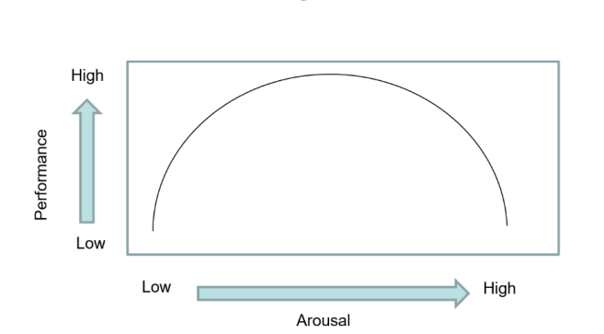
Question 29 – Inverted U hypothesis (8 marks)

 | Description | Marks
a | X axis (arousal) correctly identified and labelled | 1
a | Y axis (performance) correctly identified and labelled | 1
a | Inverted U shape appropriate | 1
a | Athletes perform best with moderate (peak) arousal levels | 1
a | Performance will not be at its best if arousal is too high or too low. | 1
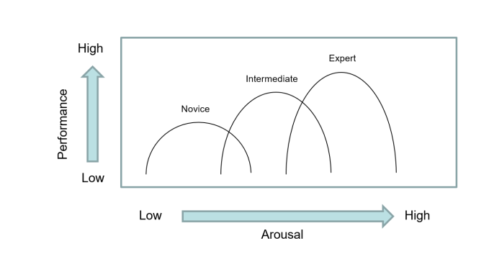
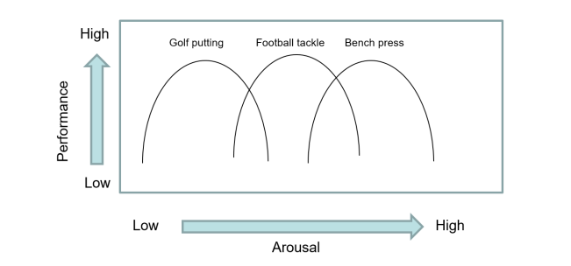

OR

 | Description | Marks
b | Accurately identifies skill level OR type of activity | 1
b | Draws graph appropriate to factor identified | 1
b | Briefly explains that beginners or complex skills need lower arousal levels | 1

Question 30 – Energy systems (9 marks)

 | Description | Marks
a | Adenosine Triphosphate (ATP) | 1
b | Lactic acid system | 1
c | Body uses up available stores of CP in muscle | 1
d | Aerobic energy system | 1
e | Carbohydrates | 1
f | ATP-PC system used for single explosive efforts eg kicking ball | 1
f | Lactic acid system used for repeated efforts when PC stores are depleted eg attacking | 1
f | Aerobic system used to regenerate ATP stores while ball not near player, stoppage | 1
f | All systems as continuously being utilised depending on what the athlete is doing | 1

Question 31 – Hitting a hockey ball (7 marks)

 | Description | Marks
a | Identify sequential summation of forces | 1
b | Use as many body parts as possible eg legs, back, trunk, shoulders, arms, hands | 1
b | Increase the distance of the stick head from impact point on the ball (bigger swing) | 1
b | Sequentially develop the force using the body parts with the greatest inertia first, then develop force over the greatest time possible | 1
b | Initiation the next segment once the previous segment has reached peak velocity | 1
b | Follow through to the target: To ensure there is no deceleration before impact and the body segments gradually slow under control – reducing the potential for injury | 1
b | Increase angular velocity/angular motion before the ball is struck | 1

Question 32 – Goal setting acronym (3 marks)

Description | Marks
S – specific – state exactly what the goal is | 1
A – action based – what does the athlete actually need to do | 1
T – timely – a specified time line for achievement | 1

SECTION THREE – EXTENDED ANSWER (30 MARKS)

Question 33 – Laws of motion and Nideffer’s model of attention (15 marks)

 | Description | Marks
a | Newton’s First Law of Motion: A body continues in its state of rest or uniform motion in a straight line, unless it is compelled to change that state, by an external force | 1
a | Creation of motion - The ball will remain on the ground until the club-head applies a force to change the ball’s state of rest (it is not moving), causing it to leave the resting position. OR The golfer must apply internal forces using muscles of the body to cause the club to move from set to the backswing positions. | 1
a | Changing the state of an object - The ball would retain a constant velocity after impact if external forces, such as gravity and air resistance, were not apparent. However, gravity applies a downward force on the ball, while air resistance reduces the velocity of the ball as it moves through the air horizontally. | 1

 | Description | Marks
c | Define 2nd law – When a body is acted upon by a force, the acceleration is proportional to the force and in the same direction | 1
c | The greater the force applied to the ball, the further it will travel | 1
c | The ball will travel in the direction of the force application | 1

 | Description | Marks
c | Define 3rd law – for every action, there is an equal and opposite reaction | 1
c | When the club applies a force to the ball, the ball applies an equal and opposite force back on the club | 1
c | By proportion of mass, the ball experiences greater acceleration as a result of this interaction between club and ball and therefore travels a greater distance | 1

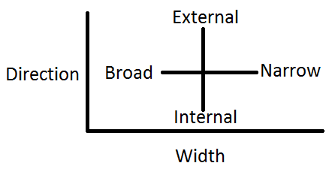
 | Description | Marks
d | Graph drawn correctly | 1
d | Broad/external – lots of cues from the external environment eg crowd | 1
d | Broad/internal – choice of multiple strategies to consider eg which club to use | 1
d | Narrow/external – focussing on ball before hitting shot | 1
d | Narrow/internal – specific thought eg keep head still | 1
d | Identify narrow external as the most applicable to golf | 1

Question 34 – Triathlon training principles & mental skills techniques (15 marks)

 | Description | Marks
a | Identify specificity - adaptations that occur are dependent upon the training undertaken. | 1
a | For an elite triathlete, to improve their ability to complete a certain exercise task, the training must be specific to the nature of that task. Therefore, when designing training programs, it is important to identify the components of fitness and the energy systems involved in the triathlon | 1
a | Identify progressive overload – stress or overload the system to produce change/adaptation | 1
 | Gradually increase the workload by increasing intensity (how hard), duration (how long) or frequency (how often) of training sessions | 1

 | Description | Marks
b | Identify continuous training | 1
b | Explained as sustained activity for long periods of time (20 – 60 minutes) | 1
b | Identify interval training | 1
b | Explained as repeated short bouts of activity followed by a period of rest or reduced activity | 1
b | Identify resistance training | 1
b | Explained as a series of exercises with resistance (weights/machines) to stress muscle group | 1

 | Description | Marks
c | Goal setting – creates a focus or target to achieve | 1
c | Relaxation – using techniques like breath control to reduce stress/arousal | 1
c | Imagery – creating mental pictures of your desired performance in your mind | 1
c | Performance routines – set ways to prepare for skill execution | 1
c | Self-talk – talking or thinking to yourself – trying to keep as positive as possible

Question 35 – Types of Motion & Motivation (15 marks)

 | Description | Marks
a | Identify linear motion | 1
a | Define as - all parts of body travel in same direction, at same time and same speed eg head of the cyclist or bike frame | 1
a | Identify angular motion | 1
a | Define as – when a body rotates about an axis at the same time, direction and angle eg rotation of the pedals | 1
a | Identify general motion as a combination of the above two types | 1

 | Description | Marks
b | Identify Velocity of release | 1
b | Define as – how fast the projectile is travelling at the time of release – greater velocity generally means increased distance travelled by projectile | 1
b | Identify Height of release | 1
b | Define as – difference between release and landing heights. If release height is higher, then angle is less than 45º, if release height is lower, angle is greater than 45º | 1
b | Identify Angle of release | 1
b | Define as – angle that determines trajectory and 45º usually maximises horizontal and vertical components of velocity | 1

 | Description | Marks
c | Identify intrinsic motivation | 1
c | Identify extrinsic motivation | 1
c | Young athletes generally require extrinsic rewards (coach approval, Trophy, chockie frog) | 1
c | Older athletes enjoy participation, challenge, socialisation of sport therefore becoming more intrinsic | 1

Question 36 – Phases of Learning & Stress Response (15 marks)

 | Description | Marks
a | Identify autonomous phase of learning | 1
a | Any six of the following;  •the athletes does not consciously think about specific movements of the skill (automatic)  •the athlete can perform other tasks at the same time  •there is low performance variability  •the athlete can detect their own errors and make adjustments to correct them  •larger and more complex sequences of movement can be performed  •athlete is more concerned with tactical implications  •errors are very small and easily corrected by the performed  •they can use cues more effectively and aren’t distracted by irrelevant information  •skills are performed at higher speed and accuracy  •make good decisions regarding the most appropriate response to the situation | 6

 | Description | Marks
b | Identify stage 1 – demands of the task | 1
b | Define as – what the athlete is being asked to do | 1
b | Identify stage 2 – athletes perception of the task | 1
b | Define as – amount of perceived threat (physical or mental) | 1
b | Identify stage 3 – stress response | 1
b | Explain how the athlete responds to the situation physically and mentally. If they perceive an imbalance between demand and ability, then stress levels will he higher | 1
b | Identify stage 4 – performance consequences | 1
b | Explain how the athlete performs, high muscle tension may result in a missed shot | 1

